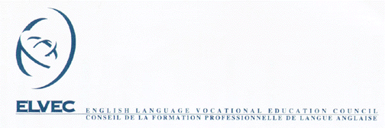

MELS – ELVEC In-Service Activities for
Vocational Training Teachers

Activity Report

Identification of the Activity
Activity Title:
Duration of Session (No. of hours)
Name of Host School Board:
Activity Contact Person at  Host School Board: |  |  | 
Animator:
Clientele: |  | Number of Participants:
 |  | Planned |  |  |  | Actual
Teachers
Others (specify)

Return to In-service Coordinator Shelley Smythe
Fax: (450) 829-2398 46 rue Roy
Email: ssmythe@nfsb.qc.ca Ormstown, QC J0S 1K0

Evaluation of the Session

On the basis of the participant evaluation forms, please indicate for each of these statements, the participants’ level of satisfaction. In each column, put the total number of participants who chose that number

(1) represents “strongly disagree” and (4) represents “strongly agree”

 | Responses |  |  |  | Total
Statements | -  1 | 2 | 3 | +  4
1. The objectives identified at the start of the session were attained.
2. The content of this activity corresponded to the objectives of the program in question.
3. The materials were of assistance.
4. The information I received during this session has helped me to develop new skills.
5. The information I received during this session is directly related to my assignment.
6. Overall, the group was satisfied with the animator.
Total:

Cost of the Animator and Related Expenses
Total cost of the fees for the animator and the expenses related to holding the activity as outlined in the specification sheet:
Fees for the Animator: | $
Accommodation and Travel Expenses: | $
Rental of Equipment: | $
Rental of Space: | $
Other (specify) | $
Total: | $
50% Financed for the Animator if Single Board. | Total Financed:___________

Documents to be Supplied


Specifications Sheet
Registration Form
List of Participants
Participant Evaluation Forms
Activity Report
Documents Produced for the Session
Other Documents Deemed Pertinent

General Comments

Signature of the contact person
of the host school board: _______________________________Date: _________________
Return to In-service Coordinator Shelley Smythe
Fax: (450) 829-2398 46 rue Roy
Email: ssmythe@nfsb.qc.ca Ormstown, QC J0S 1K0

