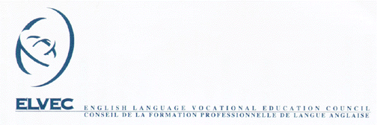

MELS – ELVEC In-Service Budget
Compensation for Training for Outlying Boards

In order to help outlying boards participate in in-service training that is needed and valuable to the teachers professional development, the following is being proposed:

Travel From Your Board To Host Board | Compensation
Travel From Your Board To Host Board | Travel | Accommodation
More than 175 kilometers (one way) | $75 | $50 per room per night for one night
More than 800 kilometers (one way) | $100 | $50 per room per night for two nights

Above based on a one-day workshop:

- Travel: For travel compensation, $75 will be allotted per car. If possible, there should be a minimum of two occupants per car. If train or plane travel is necessary for distances over 800 kilometers, compensation will be $100 per person up to a maximum of four board participants.
- Accommodation: For accommodation compensation, $50 will be allotted per room. When possible, double occupancy is requested. (when gender and number of participants permit)
One night compensation for those traveling over 175 kilometers and two night compensation for those traveling over 800 kilometers.
- For a workshop of two days duration or longer, the travel compensation remains the same, but the accommodation compensation increases to two nights if traveling over 175 kilometers, and from two nights to three nights if traveling over 800 kilometers.
- Reimbursement: No compensation can be provided to a board until appropriate documentation and receipts for expenses are submitted to the Provincial In-Service Activities Coordinator. Each board or centre should also indicate to whom the compensation cheque should be addressed: the centre or the board.
- This compensation for distance is applicable to all categories of English-language in-service activities described in the In-Service budget guidelines available on line at: www.inforoutefpt.org select English and then select Teachers’ In-service (found in left panel).

