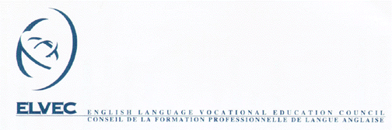

MELS – ELVEC In-Service Activities for
Vocational Training Teachers

In-Service Activities
Host’s Document Checklist

The following documents are needed in order to issue payment for any in-service activities that are run by your board.

1. | Specifications Sheet | ◻
2. | Registration Forms | ◻
3. | List of Participants | ◻
4. | Participant Evaluation Form | ◻
5. | Activity Report | ◻
6. | Receipts for Payment | ◻
7. | Documents from session or any other documents deemed pertinent | ◻

Return to In-service Coordinator Shelley Smythe
Fax: (450) 829-2398 46 rue Roy
Email: ssmythe@nfsb.qc.ca Ormstown, QC J0S 1K0

