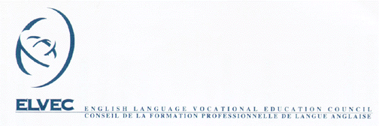

MELS – ELVEC In-Service Activities for
Vocational Training Teachers

LIST OF PARTICIPANTS

Activity Title:

Date:

Location:

Surname and First Name  (Block Letters) | Signature | Position |  | School Board
Surname and First Name  (Block Letters) | Signature | Teacher | Other | Code | Name
1.
2.
3.
4.
5.
6.
7.
8.
9.
10.
11.
12.
13.
14.
15.
16.
17.
18.
19.
20.
Return to In-service Coordinator Shelley Smythe
Fax: (450) 829-2398 46 rue Roy
Email: ssmythe@nfsb.qc.ca Ormstown, QC J0S 1K0

