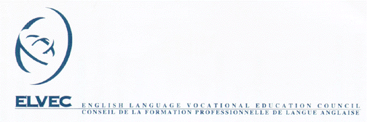

MELS – ELVEC In-Service Activities for
Vocational Training Teachers
PARTICIPANT EVALUATION FORM

Activity Title:
Activity Code: |  | Session:
Date: |  | Location:
Animator:

Please complete this form and return it to the host board contact person.

For each statement listed below, please circle the number which best represents your opinion.

(1) represents “strongly disagree” and (4) represents “strongly agree”

 | Strongly Disagree |  |  | Strongly Agree
1. The objectives identified at the start of the session were attained. | 1 | 2 | 3 | 4
2. The content of this activity corresponded to the objectives of the program in question. | 1 | 2 | 3 | 4
3. The didactic materials were of assistance. | 1 | 2 | 3 | 4
4. The information I received during this session has helped me to develop new skills. | 1 | 2 | 3 | 4
5. The information I received during this session is directly related to my assignment. | 1 | 2 | 3 | 4
6. Overall, I was satisfied with the animator. | 1 | 2 | 3 | 4

Comments, suggestions:

