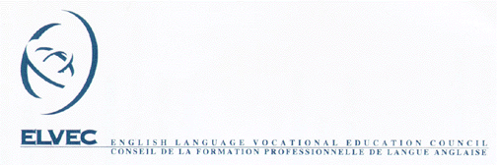

MELS – ELVEC In-Service Activities for
Vocational Training Teachers
REGISTRATION FORM

(Please fill out and return to the In-Service Coordinator)

Activity Title: |  | Host School Board:
Activity Date: |  | Contact Person:
Activity Time: |  | Tel:
Animator: |  | Fax:
Description:
 |  | Activity Site:
 |  | Tel:

Participants
Order of Priority | Surname and  First Name | Position | Language of Instruction |  | Telephone Number
Order of Priority | Surname and  First Name | Position | E | F | Workplace | Residence
1
2
3
4
5
6
Persons hereby registered have the prerequisites required to participate in the session. We agree to release them for the full length of the session.

Signature Date

Centre Director Telephone Number

Return to In-service Coordinator Shelley Smythe
Fax: (450) 829-2398 46 rue Roy
Email: ssmythe@nfsb.qc.ca Ormstown, QC J0S 1K0

